Queries 20 to 31

**20. Retrieve the employee numbers of all employees who work on project located in Bellaire, Houston, or Stafford**

SELECT ssn FROM EMPLOYEE, PROJECT WHERE Plocation = "Houston" AND Plocation = "Stafford" or Plocation = "Bellaire" or Dnum = Dno;

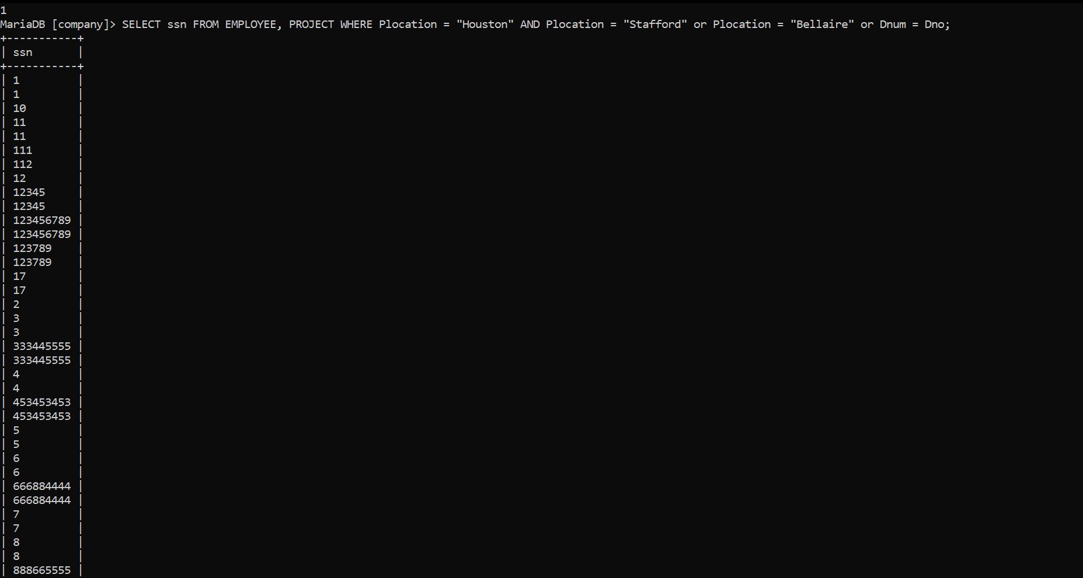

**21. Find the sum of the salaries of all employees, the maximum salary, the minimum and the average salary. Display with proper heading**

**select sum(salary) as sum_of_salary,max(salary) as max_salary,min(salary) as min_salary,avg(salary) as average_Salary from employee;**

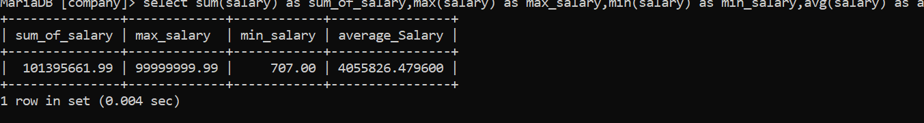

**22. Find the sum of the salaries and number of employees of all employees of the ‘Marketing’ department, as well as the maximum salary, the minimum salary, and the average salary in this department**

select sum(salary),min(Salary),avg(Salary),count(*) from employee,department where dno=dnumber and dname like "%marketing%";

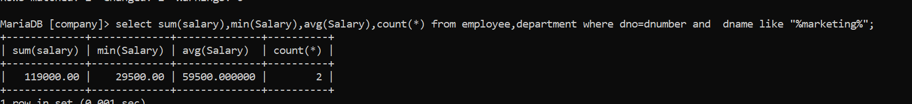

**23. Select the names of employees whose salary is greater than the average salary of all employees in department 10**

**select fname,minit,lname from employee where salary > all(select avg(salary) from employee where dno=10);**

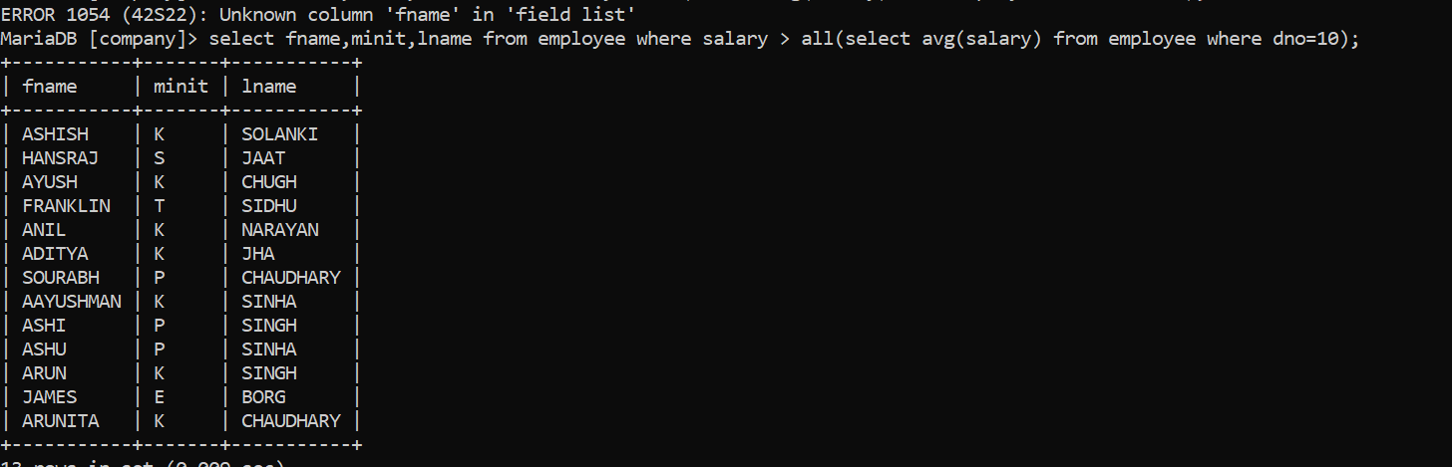

**24. For each department, retrieve the department number, the number of employees in the department, and their average salary**

select dno,count(*),avg(salary) from employee group by dno;

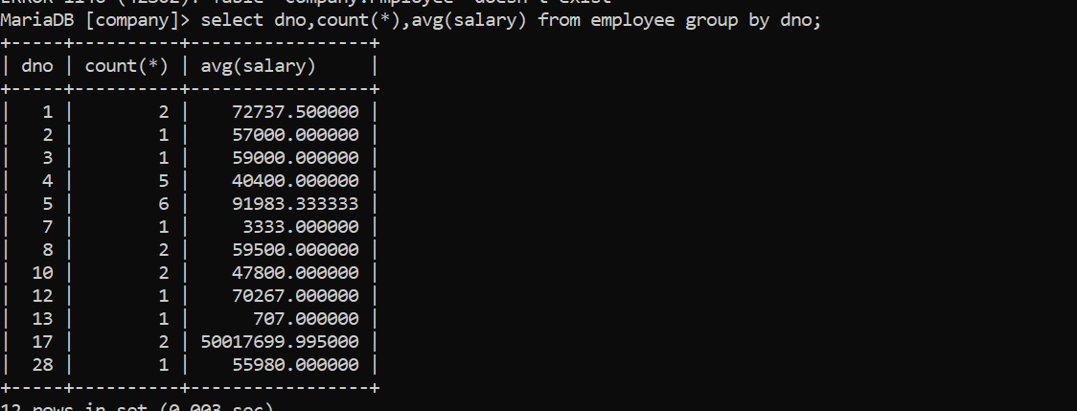

**25. For each project, retrieve the project number, the project name, and the number of employees who work on that project.**

select pnumber,pname,count(*) from project,works_on where pno=pnumber group by pno;

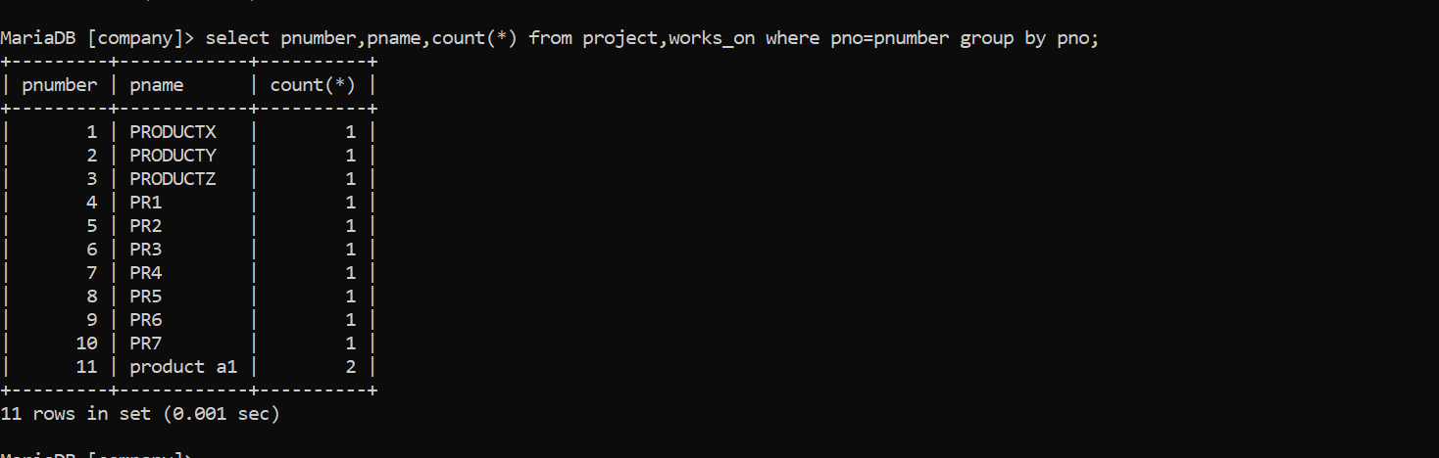

**26. Change the location and controlling department number for all projects having more than 5 employees to ‘Bellaire’ and 6 respectively**

UPDATE PROJECT SET Plocation = "Bellaire", dnum = 6 WHERE (SELECT COUNT(W.Essn) FROM WORKS_ON AS W, PROJECT AS P WHERE W.Pno = P.Pnumber)>5;

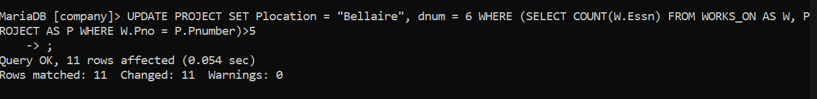

**27. For each department having more than 10 employees, retrieve the department no, no of employees drawing more than 40,000 as salary.**

**SELECT Dno FROM EMPLOYEE WHERE Salary > 40000 GROUP BY Dno HAVING COUNT(*) > 10;**

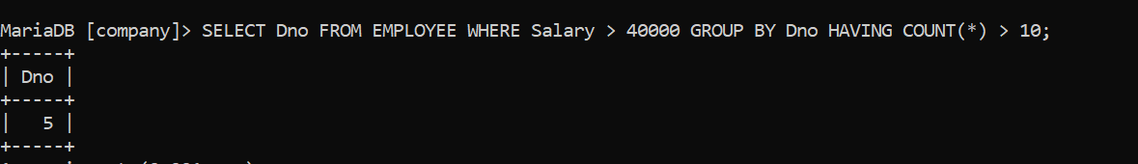

**28. Insert a record in Project table which violates referntial integrity constraint with respect to Department number. Now remove the violation by making necessary insertion in the Department table.**

**INSERT INTO PROJECT VALUES ("Safar", 17, "Houston", 25);**

**insert into department values('study','25','1212122','2010-12-13');**

**INSERT INTO PROJECT VALUES ("Safar", 17, "Houston", 25);**



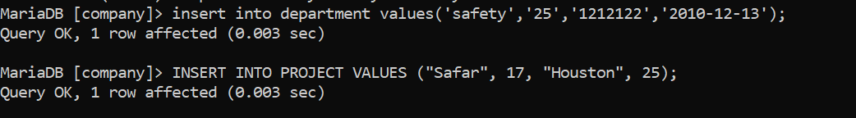

**29. Delete all dependents of employee whose ssn is ‘123456789**

DELETE FROM DEPENDENT WHERE Essn = (SELECT Ssn FROM EMPLOYEE WHERE Ssn = "123456789");

